## **ABSTRACT**

In the recent years, there is a major development in field of automation with microcontroller. So, a legitimate level control framework is important to abstain from spreading some destructive situation. The main aim of this project is to identify the level of water tank(high or low), detect it by using conductivity method and communicate through a microcontroller that in turn provides control strategy.

The main components used in making this prototype are AT89S52 MCU, . The software components are the application named as Keil UVision 5 which is used to write and ProgISP to dump the program to the MCU. This Prototype can be a start to Smart level identification and control System where the industries can automatically on or off the pump based upon the given level.

## **TABLE OF CONTENTS**

**CHAPTER TITLE PAGE**

**NO**  **NO**

ABSTRACT

LIST OF FIGURES

1. INTRODUCTION
   1. OVERVIEW 1
   2. OBJECTIVE 1
   3. ORGANISATION OF THE THESIS 1
2. DESIGN AND SPECIFICATION
   1. HARDWARE REQUIREMENTS 2

2.2 SOFTWARE REQUIREMENTS 10

2.3 DESIGN OF THE MODEL 11

* + 1. CIRCUIT DIAGRAM 11

2.4 C-CODE 11

2.5 LIVE SETUP 15

* + 1. LIVE SETUP CONNECTION 15

3 METHODOLOGY

* 1. SENSING PART 16

3.2 CONTROLLING PART 17

4 RESULTS AND DISCUSSION

4.1 OBSERVATION 18

4.2 MERITS AND APPLICATIONS 20

### 

### 5 CONCLUSION AND FUTURE

SCOPE

5.1 CONCLUSION 21

#### 5.2 FUTURE ENHANCEMENTS 21

##### REFERENCES 21

|  |  |
| --- | --- |
| **LIST OF FIGURES** |  |
| **FIG NO.** **TITLE** | **PAGE**  **NO** |

2.1 8051 DEVELOPMENT BOARD 3

2.2 PIN DIAGRAM OF AT89S52 MCU 4

2.3 PIN DIAGRAM OF LCD DISPLAY (LM016L) 5

2.4 8051 AVR USB ISP PROGRAMMER 6

2.5 RELAY PIN TERMINALS WITH INTERNAL 7

CIRCUIT DIIAGRAM

2.6 WATER PUMP 7

2.7 2N2222 NPN TRANSISTOR 8

2.8 1N4007 DIODE 8

2.9 RESISTOR (1 KOhm) 9

2.10 BREADBOARD 9

2.11 CONNECTING WIRES 10

2.12 PROTEUS CONNECTION OF THE LEVEL 11

CONTROL

2.13 ACTUAL SETUP USING HARDWARE 15

4.1 RESULT FROM PROTEUS SIMULATION (BEFORE 19

LEVEL REACHES THE MAXIMUM POINT)

4.2 RESULT FROM PROTEUS SIMULATION (AFTER 19

LEVEL REACHES THE MAXIMUM POINT)

**CHAPTER 1**

**INTRODUCTION**

#### **1.1 OVERVIEW**

As the technology grows day by day, the field of automation also grows exponentially to it. It’s really a high time to control as well as the monitor the level in tanks in houses for small purpose or in industry where we control them.

#### **1.2 OBJECTIVE**

Level maintenance is intended to make the control of pump to maintain a particular level in the tank. This project mainly focuses on identifying the level the tank remotely from any area and to operate the controller without contact. This project is designed with a notion to have a automated life system around us.

#### **1.3 ORGANISATION OF THE THESIS**

* Chapter 1 focuses on the objective of the project and the importance of it in our environment.
* Chapter 2 deals with the literature survey and ideas of the project.
* Chapter 3 shows the design and specification of the hardware components used in the project. It also talks about the software that has been implemented in the project.
* Chapter 4 presents the methodology used for designing this project.

* Chapter 5 presents the implementation and simulation results of the project.

* Chapter 6 presents the conclusion and future scope of the project.

**CHAPTER 2**

## **DESIGN AND SPECIFICATION**

The project’s motive is to design an automatic on and off the water pump and also identify the level continuously and transmit it through a microcontroller and display in the LCD.

## **2.1 HARDWARE REQUIREMENTS**

The materials that are required are:

1. 8051 DEVELOPMENT BOARD

A) AT89S52 MICROCONTROLLER

B) 16X2 LCD DISPLAY (LM016L)

1. 8051 AVR USB ISP PROGRAMMER
2. RELAY
3. WATER PUMP
4. TRANSISTOR (2N2222)
5. 1N4007 DIODE
6. RESISTORS (1 KOhm)
7. BREADBOARD AND CONNECTING WIRES

**1. 8051 DEVELOPMENT BOARD :**

The 8051 development board .This board contains on board device such as 16x2 LCD display (LM016L),DS1307 RTC, Port expander, Power supply circuit,RS232 port for serial communication, Power status led(red),reset switch, user switch, user led(green) that interface with 8051 microcontroller the board is compatible with the AT89S51/52 and the P89V51RD2 microcontrollers.

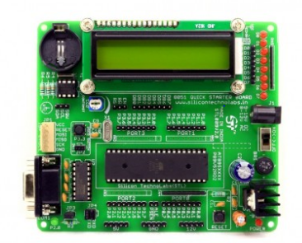

**FIG:2.1 8051 DEVELOPMENT BOARD**

# **AT89S52 MICROCONTROLLER:**

The AT89S52 comes from the popular 8051 family of Atmel Microcontrollers. It is an 8-bit CMOS microcontroller with 8K as Flash memory and 256 bytes of RAM. Since it is similar to the trust worthy 8051 architecture, these microcontrollers are as per industry standard. It has 32 I/O pins comprising of three 16-bit timers,external interrupts, full-duplex serial port, on-chip oscillator and clock circuitry. The Microcontroller also has operating mode, Idle mode and power down mode which makes it suitable for battery operated applications.

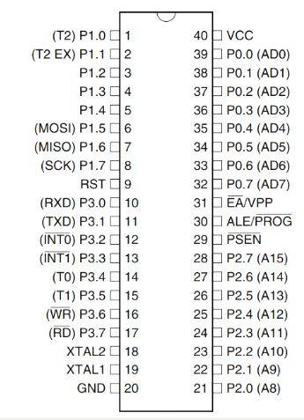

**Fig 2.2 Pin Diagram of AT89S52 MCU**

1. **16X2 LCD DISPLAY (LM016L):**

An LCD (Liquid Crystal Display) screen is an electronic display module and has a wide range of applications. A 16x2 LCD display is very basic module and is very commonly used in various devices and circuits. A 16x2 LCD means it can display 16 characters per line and there are 2 such lines. In this LCD each character is displayed in 5x7 pixel matrix. The 16 x 2 intelligent alphanumeric dot matrix display is capable of displaying 224 different characters and symbols. This LCD has two registers, namely, Command and Data. Command registers stores various commands given to the display. Data register stores data to be displayed. The process of controlling the display involves putting the data that form the image of what you want to display into the data registers, then putting instructions in the instruction register.

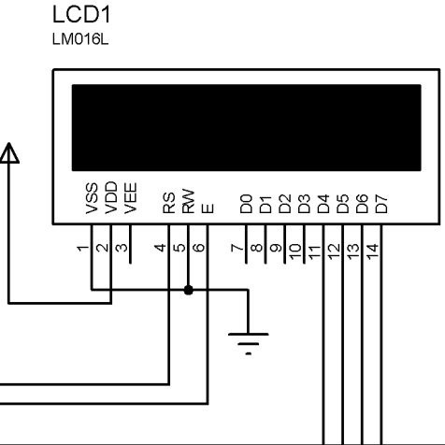

### **Fig 2.3 Pin Diagram of LCD (LM016L)**

**2. 8051 AVR USB ISP PROGRAMMER:**

ATMAL AVR and 8051 ISP Programmer is low cost USB based programmer. Easy to use, works with AVRDude, This is ISP(In System Programmer) therefore you can program your target microcontroller without removing it from your development board. This programmer will work with a wide variety of Atmel AVR and AT89SXX microcontroller. One of the greatest features of this board is the ability to power the target (up to 500mA) from the programmer.

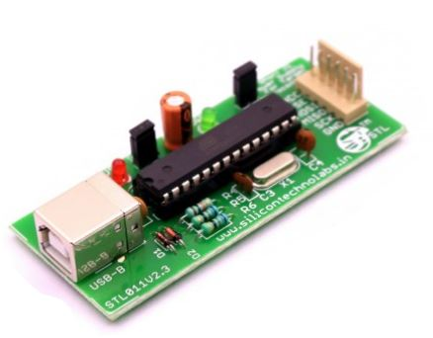

**FIG:2.4 8051 AVR USB ISP PROGRAMMER**

**3. RELAY (5 volts):**

Relay is an electro-mechanical component that functions as a switch. The relay coil is energized by DC so that contact switches can be opened or closed. A single channel 5V relay module generally includes a coil, and two contacts like normally open (NO) and normally closed (NC).

PIN 1(TERMINAL): It is used to activate the relay. This pin is connected to 5 Volts.

PIN 2(TERMINAL): This pin is connected to ground.

PIN 3(COMMON) : This pin is connected to the main terminal of the load to make it active.

PIN 4(NC) : (Normally closed)-If this pin is connected to the load then the

circuit will become open when the coil is energized

PIN 5(NO) : (Normally opened)-If this pin is connected to the load then the circuit will become closed when the coil is energized

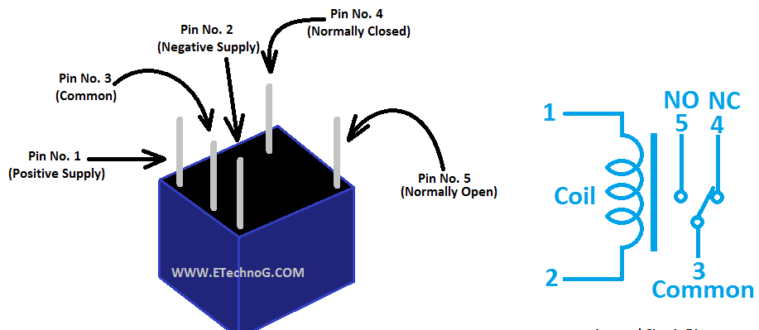

**FIG: 2.5 RELAY PIN TERMINALS WITH INTERNAL CIRCUIT DIAGRAM**

**4.WATER PUMP:**

This is a low cost, small size submersible pump motor which can be operated from 3V to 9V power supply. It can take up to 120 litres per hour with a very low current consumption of 220mA.

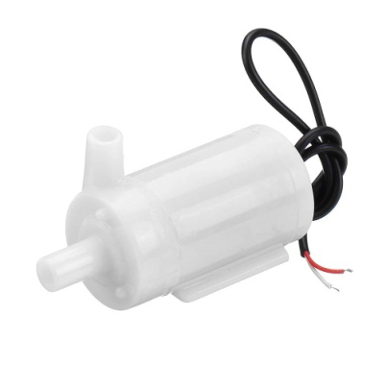

**FIG.2.6 WATER PUMP**

**5.TRANSISTOR-(2N2222):**

The 2N2222 transistor is a common NPN BJT & it is mainly used in the applications of switching & amplifying with less power. This transistor is mainly designed for low power, low to medium current, medium voltage & works at fairly high speeds. In the 2N2222 NPN transistor, a single P-doped layer is embedded among two N-doped layers. This transistor includes three terminals like Base, Emitter & Collector. 2N2222 transistor offers constant DC collector current so it is used where low to medium current is necessary.

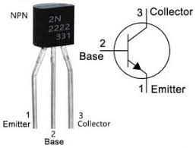

**FIG: 2.7 2N2222 NPN TRANSISTOR**

**6. 1N4007 DIODE:**

1N4007 is a rectifier diode. It can pass currents of upto 1A and have peak inverse voltage of 1000 V. The lead near to the silver line is the cathode and the other lead is anode. Here it is used as a protection for relay.

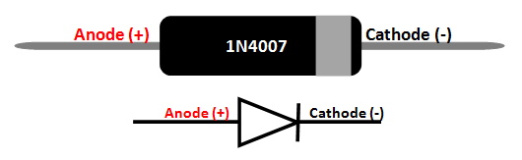

**FIG: 2.8 1N4007 DIODE**

**7. RESISTORS (1KOhm):**

Passive electrical component with two terminals with two terminals to regulate the flow of electric current.

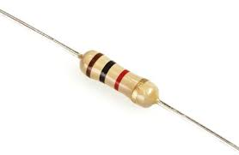

**FIG: 2.9 RESISTOR 1KOHM**

**8.BREADBOARD AND CONNECTING WIRES:**

Breadboard:

Used for building temporary circuits. Allows to place components and connections in the circuit without soldering.

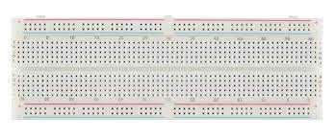

**FIG:2.10 BREADBOARD**

Connecting wires:

They are usually made up of copper and is provided with insulation to make electrical connections between two points.

SENSING ELEMENT:

As these wires conducts electricity ,they are used as means of indicating level of water (as water also acts a conducting medium).

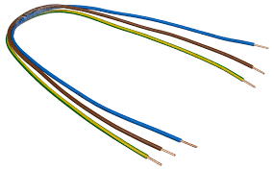

**FIG: 2.11 CONNECTING WIRES**

#### **2.2 SOFTWARE REQUIREMENTS:**

In this project we have used KEIL UVISION 5 to code the c program and PROGISP(Version 1.72) to interface with 8051 AVR USB ISP programmer to dump the hex file in 8051 Microcontroller. For simulation, Proteus 8 Professional (Version 8.13) is used.

#### **2.3 DESIGN OF THE MODEL**

##### **2.3.1 CIRCUIT DIAGRAM**

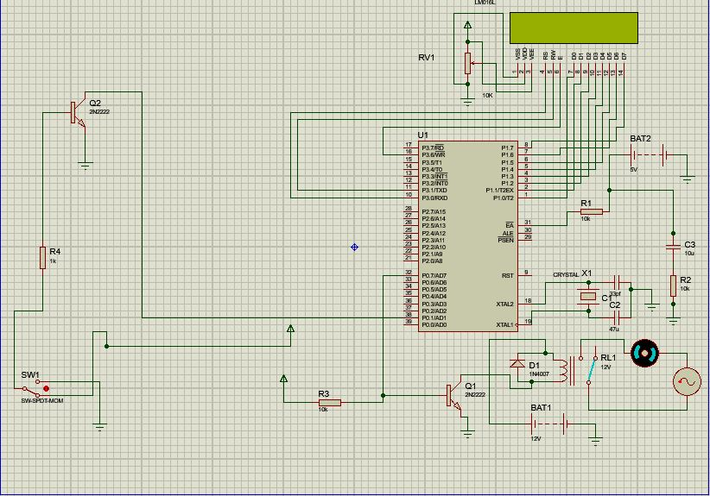

**FIG: 2.12 PROTEUS CONNECTION OF THE LEVEL CONTROL**

The Fig 2.8 depicts the connection of level control strategy. The connecting wire(which is used as a sensing element to indicate the level) is connected to the base of the transistor(through the resistor).The emitter of the transistor is grounded and the collector is connected to one of the pins of PORT 0(P0.1) of AT89S52 MCU. The LCD is connected to PORT 1 and PORT 3 that displays the current level and the status of the pump (whether the pump is in off or on condition). The relay has been connected through a transistor to P0.7 Pin which is used to control the pump.

#### **2.4 SOURCE CODE**:

#include <REGX52.h>

#define msec 50

sbit rs=P3^0;

sbit rw=P3^1;

sbit en=P3^6;

sbit high=P0^1;

sbit relay=P0^7;

unsigned char commands[]={0x38,0x0E,0x01,0x06,0x81,'\0'};

unsigned char name1[]={"Level:High"};

unsigned char name2[]={"Level:Low"};

unsigned char name3[]={"Motor:On"};

unsigned char name4[]={"Motor:Off"};

void delay(unsigned int time)

{

unsigned int i,j;

for(i=0;i<time;i++)

for(j=0;j<1250;j++);

}

void lcdcmd(unsigned char val)

{

P1 = val;

rs = 0;

rw = 0;

en = 1;

delay(1);

en = 0;

}

void display(int val)

{

P1 = val;

rs = 1;

rw = 0;

en = 1;

delay(1);

en = 0;

}

void main()

{

int i,j;

for(i=0;commands[i]!='\0';i++)

{

lcdcmd(commands[i]);

delay(msec);}

if(high==1)

{

relay=0;

for(j=0;j<=10;j++)

{

display(name1[j]);

}

delay(msec);

lcdcmd(0xc1);

delay(msec);

delay(msec);

for(j=0;j<=9;j++)

{

display(name4[j]);

}

delay(msec);

}

else

{

relay=1;

for(j=0;j<=9;j++)

{

display(name2[j]);

}

delay(msec);

lcdcmd(0xc1);

delay(msec);

delay(msec);

for(j=0;j<=8;j++)

{

display(name3[j]);

}

delay(msec);

}

}

##### **2.5 LIVE SETUP**

##### **2.5.1 LIVE SETUP CONNECTION**

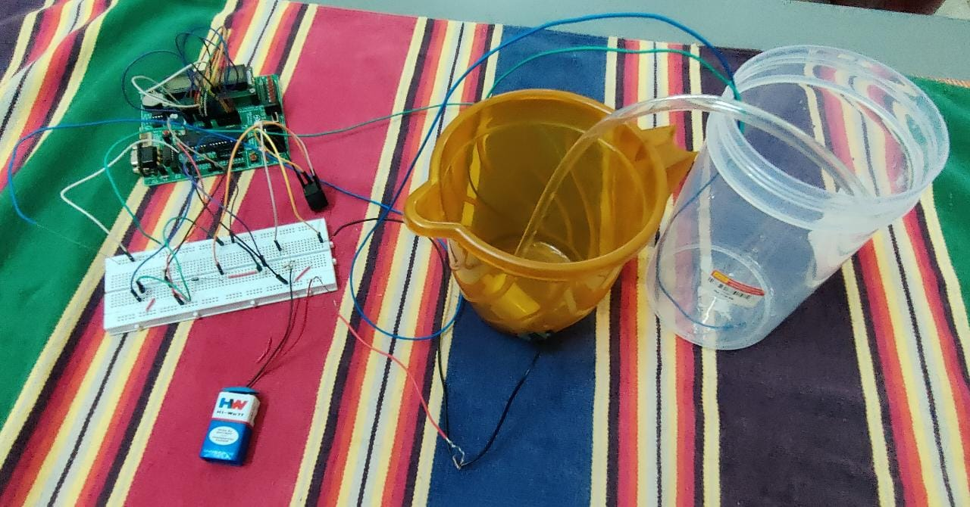

**Fig 2.13 Actual Setup Using Hardware**

**CHAPTER 3**

**METHODOLOGY**

#### **3.1 SENSING PART**

Two probes(connecting wires) are arranged in an overhead tank

One of the probe is connected to a 5 Volt power supply and is placed at the bottom of the tank.

Another probe is fixed at the maximum level.

When the level has not reached the second probe,there is no passage for the current to

pass through from the primary (low level indication).

★ When the level has reached the second probe,then there is a passage for the current

to pass through from the primary probe(as water can act as a conducting medium for

electric current).

★ The second probe is connected to a 2N2222 Transistor’s Base through a

resistor(1Kohm).

★ The emitter of the transistor is grounded and the collector is connected to the

Pin P0.1 (PORT 0) of AT89S52 MCU.

★ The level of the tank is displayed in the LCD along with the current status of the

water pump.

#### **3.3 CONTROLLING PART**

★ The relay is connected to Pin0.7 (PORT 0) through 2N2222 transistor

★ The relay acts as a switch for the water pump

★ This relay is externally supplied by a 5V power supply

★ Until the level is less than or equal to maximum level the relay will be in Normally open position by giving 1 as an output to pin P0.7

★ While relay is in NO Mode the pump will supply water to the tank

★ Once the level goes beyond the maximum point the relay will switch to NC (Normally closed) Mode

★ Hence the pump will turn off and there is no supply of water to the tank

★ Thus the level controlling is being is implemented

**CHAPTER 4**

**RESULT AND DISCUSSION**

**4.1 RESULT:**

Two metal conductors are placed high and low level of the water tank. One metal conductors is connected to the base of 2N2222 each respectively. When water level is high both the conductors are conducted resulting in turning on both transistors. As a result the pin connected to relay turns it off, so pump turns on. Water level as high and motor status as OFF is displayed on the LCD

When water level falls below the high level, only one transistor is turned on as a result relay is turned ON, powering the motor. The motor keeps running till level becomes high. LCD shows water level as low and motor as ON

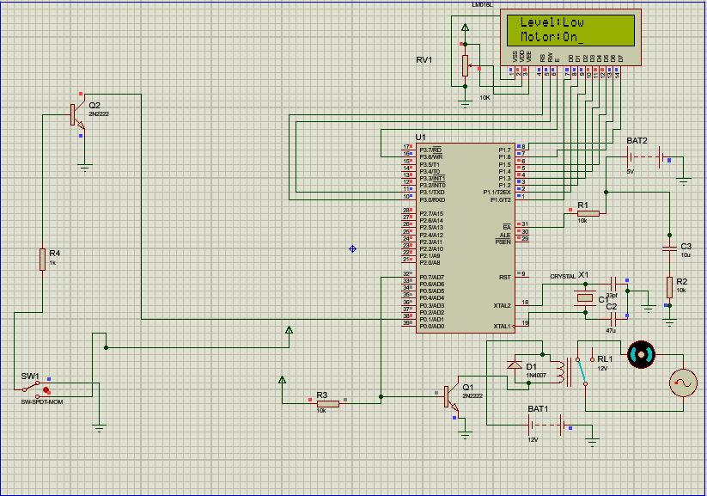

**Fig 4.1 Result from the Proteus simulation (before level reaches the maximum point)**

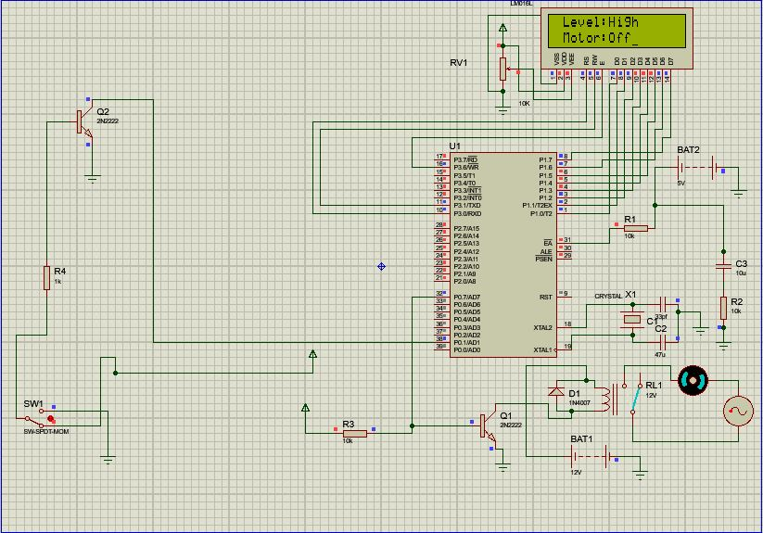

**Fig 4.2 Result from the Proteus simulation (after level reaches the maximum point)**

The Fig 4.1 and Fig 4.2 shows the simulation circuit result at the point where the level is below and above the maximum point respectively

#### **4.2 MERITS AND APPLICATIONS**

MERITS:

A reduction in the amount of manpower for the manual controlling part

Less power consumption

★ Minimal Cost

★ Simple design

APPLICATION:

★ Used in industries to control the liquid level automatically.

★ Used in places where manual monitoring is difficult.

**CHAPTER 5**

**CONCLUSION AND FUTURE SCOPE**

#### **5.1 CONCLUSION**

Microcontrollers are the futures. Every work that requires a human power can be automated if we have a good microcontroller and a deep understanding how it works. Though our project is a tiny bit of automation even now a days in most of the industries controlling the most important variable (level, pressure, temperature etc.) is being automated to reduce the man power and human error. The most important aspects of these microcontrollers are that they can be reprogrammable by the user and hence can be used based on the required purpose

#### **5.2 FUTURE SCOPE**

The Future scope of this project includes

* Creating a prototype model which can be fixed in an industry-based scenario
* Increasing the number of levels and change the rate at which

the pump supplies water according to the level

##### **REFERENCES**

* https://www.microchip.com/en-us/product/AT89S52
* https://docs.microsoft.com/en-us/cpp/c-language
* On_Off_Control.pptx by Dr. S. Meyyappan